Entity Relationship Diagram

# DVDStore Entity Relationship Diagram

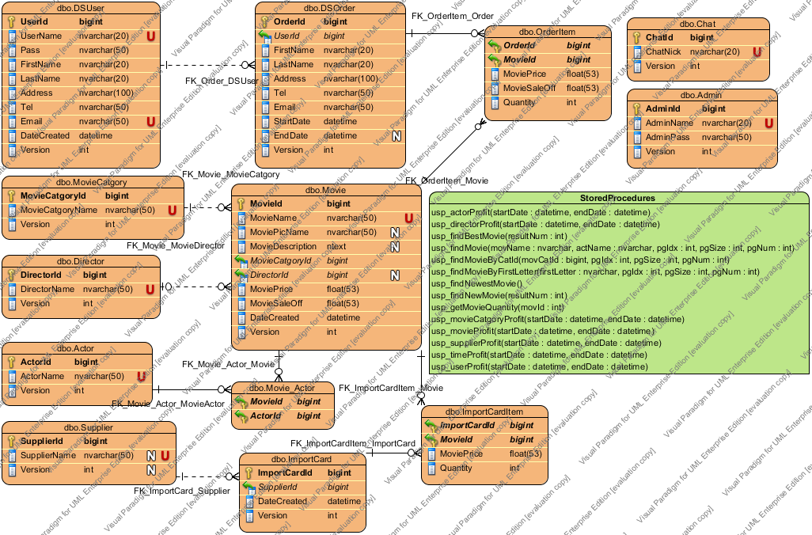

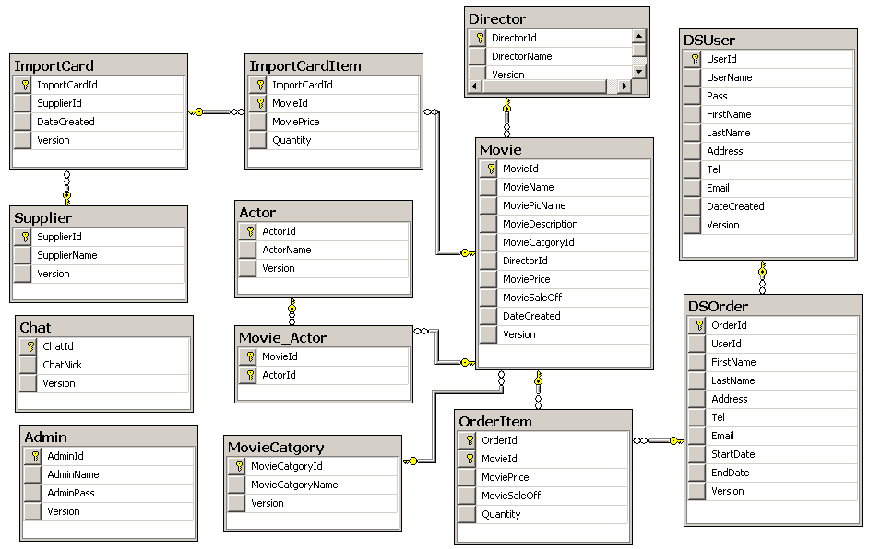

## Details

### DSUser

#### Columns Summary

|  |  |  |  |  |
| --- | --- | --- | --- | --- |
| Name | DataType | Constraints | Nullable | Documentation |
| UserId | bigint | PK | No |  |
| UserName | nvarchar(20) | Unique | No |  |
| Pass | nvarchar(50) |  | No |  |
| FirstName | nvarchar(20) |  | No |  |
| LastName | nvarchar(20) |  | No |  |
| Address | nvarchar(100) |  | No |  |
| Tel | nvarchar(50) |  | No |  |
| Email | nvarchar(50) | Unique | No |  |
| DateCreated | datetime |  | No |  |
| Version | int |  | No |  |

### DSOrder

#### Columns Summary

|  |  |  |  |  |
| --- | --- | --- | --- | --- |
| Name | DataType | Constraints | Nullable | Documentation |
| OrderId | bigint | PK | No |  |
| UserId | bigint | FK (DSUser.UserId) | No |  |
| FirstName | nvarchar(20) |  | No |  |
| LastName | nvarchar(20) |  | No |  |
| Address | nvarchar(100) |  | No |  |
| Tel | nvarchar(50) |  | No |  |
| Email | nvarchar(50) |  | No |  |
| StartDate | datetime |  | No |  |
| EndDate | datetime |  | Yes |  |
| Version | int |  | No |  |

### Chat

#### Columns Summary

|  |  |  |  |  |
| --- | --- | --- | --- | --- |
| Name | DataType | Constraints | Nullable | Documentation |
| ChatId | bigint | PK | No |  |
| ChatNick | nvarchar(20) | Unique | No |  |
| Version | int |  | No |  |

### OrderItem

#### Columns Summary

|  |  |  |  |  |
| --- | --- | --- | --- | --- |
| Name | DataType | Constraints | Nullable | Documentation |
| OrderId | bigint | PK/FK (DSOrder.OrderId) | No |  |
| MovieId | bigint | PK/FK (Movie.MovieId) | No |  |
| MoviePrice | float(53) |  | No |  |
| MovieSaleOff | float(53) |  | No |  |
| Quantity | int |  | No |  |

### Admin

#### Columns Summary

|  |  |  |  |  |
| --- | --- | --- | --- | --- |
| Name | DataType | Constraints | Nullable | Documentation |
| AdminId | bigint | PK | No |  |
| AdminName | nvarchar(20) | Unique | No |  |
| AdminPass | nvarchar(50) |  | No |  |
| Version | int |  | No |  |

### MovieCatgory

#### Columns Summary

|  |  |  |  |  |
| --- | --- | --- | --- | --- |
| Name | DataType | Constraints | Nullable | Documentation |
| MovieCatgoryId | bigint | PK | No |  |
| MovieCatgoryName | nvarchar(50) | Unique | No |  |
| Version | int |  | No |  |

### Movie

#### Columns Summary

|  |  |  |  |  |
| --- | --- | --- | --- | --- |
| Name | DataType | Constraints | Nullable | Documentation |
| MovieId | bigint | PK | No |  |
| MovieName | nvarchar(50) | Unique | No |  |
| MoviePicName | nvarchar(50) |  | Yes |  |
| MovieDescription | ntext |  | Yes |  |
| MovieCatgoryId | bigint | FK (MovieCatgory.MovieCatgoryId) | No |  |
| DirectorId | bigint | FK (Director.DirectorId) | Yes |  |
| MoviePrice | float(53) |  | No |  |
| MovieSaleOff | float(53) |  | No |  |
| DateCreated | datetime |  | No |  |
| Version | int |  | No |  |

### Director

#### Columns Summary

|  |  |  |  |  |
| --- | --- | --- | --- | --- |
| Name | DataType | Constraints | Nullable | Documentation |
| DirectorId | bigint | PK | No |  |
| DirectorName | nvarchar(50) | Unique | No |  |
| Version | int |  | No |  |

### Actor

#### Columns Summary

|  |  |  |  |  |
| --- | --- | --- | --- | --- |
| Name | DataType | Constraints | Nullable | Documentation |
| ActorId | bigint | PK | No |  |
| ActorName | nvarchar(50) | Unique | No |  |
| Version | int |  | No |  |

### Movie_Actor

#### Columns Summary

|  |  |  |  |  |
| --- | --- | --- | --- | --- |
| Name | DataType | Constraints | Nullable | Documentation |
| MovieId | bigint | PK/FK (Movie.MovieId) | No |  |
| ActorId | bigint | PK/FK (Actor.ActorId) | No |  |

### ImportCardItem

#### Columns Summary

|  |  |  |  |  |
| --- | --- | --- | --- | --- |
| Name | DataType | Constraints | Nullable | Documentation |
| ImportCardId | bigint | PK/FK (ImportCard.ImportCardId) | No |  |
| MovieId | bigint | PK/FK (Movie.MovieId) | No |  |
| MoviePrice | float(53) |  | No |  |
| Quantity | int |  | No |  |

### Supplier

#### Columns Summary

|  |  |  |  |  |
| --- | --- | --- | --- | --- |
| Name | DataType | Constraints | Nullable | Documentation |
| SupplierId | bigint | PK | No |  |
| SupplierName | nvarchar(50) | Unique | Yes |  |
| Version | int |  | Yes |  |

### ImportCard

#### Columns Summary

|  |  |  |  |  |
| --- | --- | --- | --- | --- |
| Name | DataType | Constraints | Nullable | Documentation |
| ImportCardId | bigint | PK | No |  |
| SupplierId | bigint | FK (Supplier.SupplierId) | No |  |
| DateCreated | datetime |  | No |  |
| Version | int |  | No |  |

#### Stored Procedures

|  |  |
| --- | --- |
| usp_actorProfit(startDate : datetime, endDate : datetime) | |
| Description | Nhận vào tham số kiểu datetime, xác định thời điểm bắt đầu và kết thúc báo cáo  Trả về resultset gồm các cột: ActorId, ActorName, ActSN, ActTN, ActSX, ActTX, tương ứng là mã diễn viên, tên diễn viên, số phim nhập vào, số tiền chi, số phim bán ra, số tiền thu  Yêu cầu: Lấy toàn bộ dữ liệu về diễn viên đang có trong CSDL, diễn viên nào chưa có phim bán được trả về gia trị 0 |
| usp_directorProfit(startDate : datetime, endDate : datetime) | |
| Description | Giống actorProfit |
| usp_findBestMovie(resultNum : int) | |
| Description | Nhận tham số là số phim bán chạy, phim bán chạy được lấy theo thứ tự giảm dần số phim bán ra  Trả về ResultSet gồm các cột MovieId, MovieName, MoviePicName, MovieDescription, MovieCatgoryId, DirectorId, MoviePrice, MovieSaleOff, DateCreated, Version |
| usp_findMovie(movName : nvarchar, actName : nvarchar, pgIdx : int, pgSize : int, pgNum : int) | |
| Description | Nhận vào tham số là tên phim tên diễn viên, page index, page size (số phim /trang), page num OUTPUT parameter  Trả về resultset gồm: MovieId, MovieName, MoviePicName, MovieDescription, MovieCatgoryId, DirectorId, MoviePrice, MovieSaleOff,m.DateCreated,Version  Có 1 output parameter: số trang |
| usp_findMovieByCatId(movCatId : bigint, pgIdx : int, pgSize : int, pgNum : int) | |
| Description | Tương tự usp_findMovie |
| usp_findMovieByFirstLetter(firstLetter : nvarchar, pgIdx : int, pgSize : int, pgNum : int) | |
| Description | Tương tự usp_findMovie |
| usp_findNewestMovie() | |
| Description | Lấy ra phim mới nhất (theo dateCreated trong bảng Movie)  Trả về resultset gồm các cột: MovieId, MovieName, MoviePicName, MovieDescription, MovieCatgoryId, DirectorId, MoviePrice, MovieSaleOff, DateCreated, Version |
| usp_findNewMovie(resultNum : int) | |
| Description | Lấy ra phim mới (lấy theo thứ tự giảm dần dateCreated)  Nhận tham số là số lượng phi m muốn lấy |
| usp_getMovieQuantity(movId : int) | |
| Description | Lấy ra số lượng phim hiện có trong kho |
| usp_movieCatgoryProfit(startDate : datetime, endDate : datetime) | |
| Description | Giống actorProfit |
| usp_movieProfit(startDate : datetime, endDate : datetime) | |
| Description | Giống actorProfit |
| usp_supplierProfit(startDate : datetime, endDate : datetime) | |
| Description | Giống actorProfit |
| usp_timeProfit(startDate : datetime, endDate : datetime) | |
| Description | Giống actorProfit |
| usp_userProfit(startDate : datetime, endDate : datetime) | |
| Description | Giống actorProfit |